**PEMROGRAMAN MOBILE**

**Dosen : I Ketut Resika Arthana, S.T., M.Kom.**

Tugas QR-Code



Disusun Oleh :

**JURUSAN PENDIDIKAN TEKNIK INFORMATIKA**

**FAKULTAS TEKNIK DAN KEJURUAN**

**UNIVERSITAS PENDIDIKAN GANESHA**

**SINGARAJA**

**2020**

**A. TAMPILAN PROGRAM**

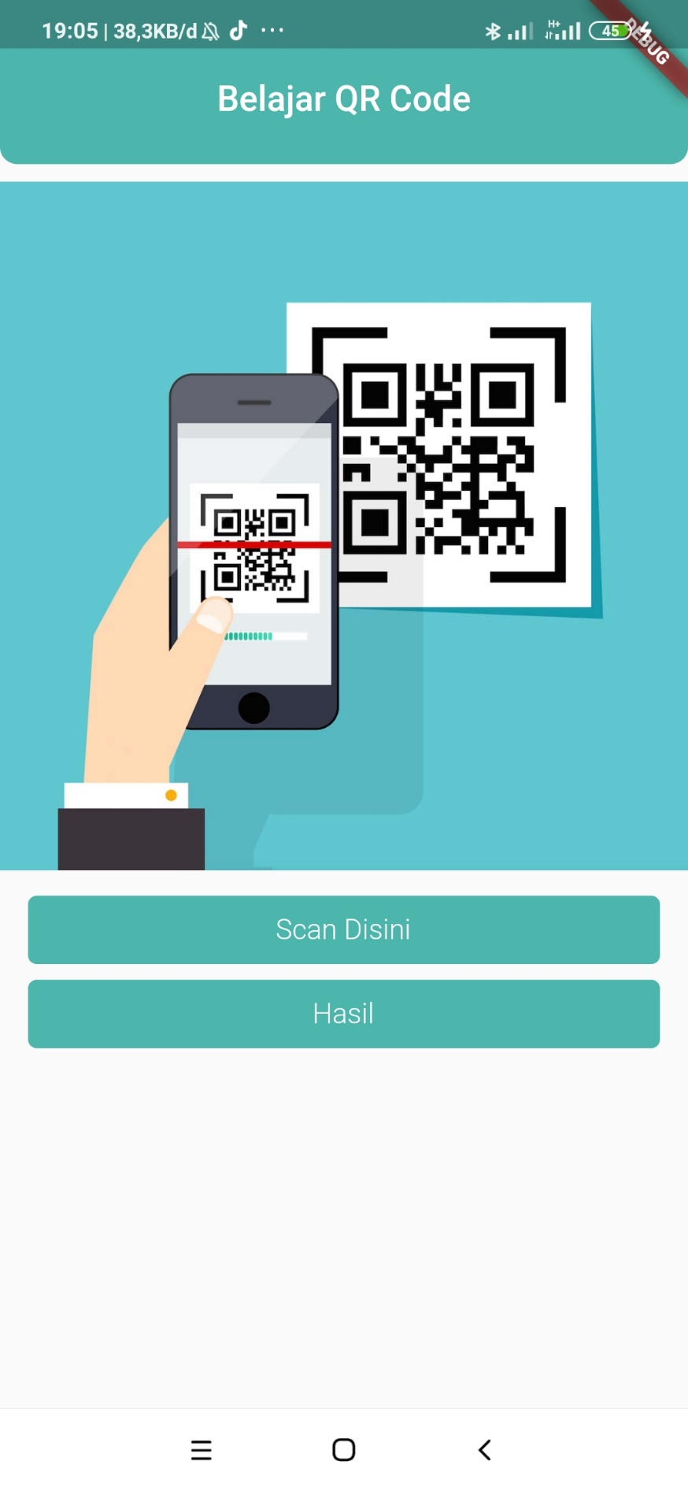

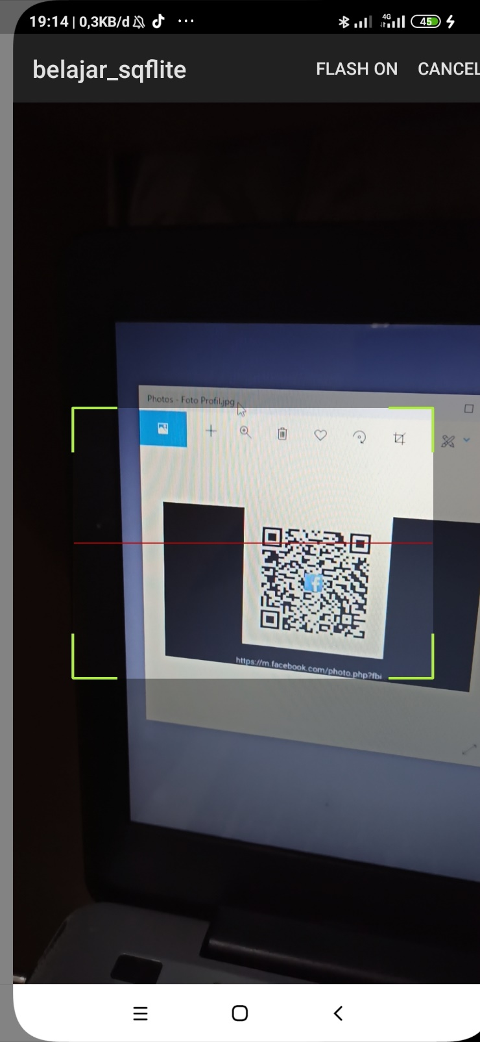

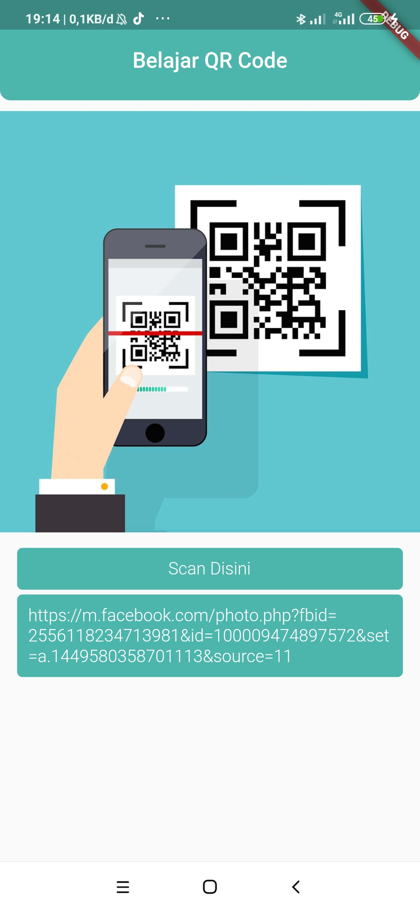

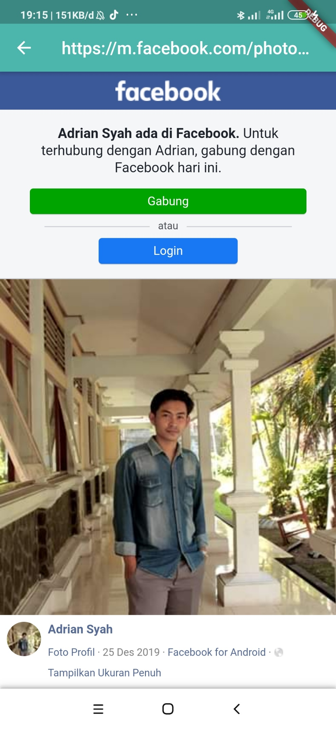

**B. SOURCE CODE :**

**Main.dart**

import 'package:flutter/material.dart';

import './screens/home_screen.dart';

void main() => runApp(MyApp());

class MyApp extends StatelessWidget {

  @override

  Widget build(BuildContext context) {

    return MaterialApp(

      home: HomeScreen(),

    );

  }

}

**screens/home_screen.dart**

import 'package:flutter/material.dart';

import 'package:barcode_scan/barcode_scan.dart';

import './webview_screen.dart';

class HomeScreen extends StatefulWidget {

  @override

  _HomeScreenState createState() => _HomeScreenState();

}

class _HomeScreenState extends State<HomeScreen> {

  String kode = "";

  var getKode;

  Future scanBarcode() async {

    getKode = await BarcodeScanner.scan();

    setState(() {

      kode = getKode.rawContent;

    });

  }

  @override

  Widget build(BuildContext context) {

    return Scaffold(

      appBar: AppBar(

        title: Text("Belajar QR Code"),

        centerTitle: true,

        backgroundColor: Colors.teal[300],

        elevation: 0.0,

      ),

      body: Column(

        children: [

          Container(

            height: 10,

            decoration: BoxDecoration(

              color: Colors.teal[300],

              borderRadius: BorderRadius.only(

                bottomLeft: Radius.circular(16.0),

                bottomRight: Radius.circular(16.0),

              ),

            ),

          ),

          SizedBox(

            height: 10.0,

          ),

          Image.network(

              "https://www.teachhub.com/sites/default/files/field/image/technology-in-the-classroom-qr-codes.jpg"),

          SizedBox(

            height: 10.0,

          ),

          FlatButton(

            onPressed: () {

              scanBarcode();

            },

            child: Container(

              width: double.infinity,

              child: Padding(

                padding: const EdgeInsets.all(10.0),

                child: Center(

                  child: Text(

                    "Scan Disini",

                    style: TextStyle(

                      color: Colors.white,

                      fontWeight: FontWeight.w300,

                      fontSize: 16,

                    ),

                  ),

                ),

              ),

              decoration: BoxDecoration(

                color: Colors.teal[300],

                borderRadius: BorderRadius.all(Radius.circular(5.0)),

              ),

            ),

          ),

          FlatButton(

            onPressed: kode == ""

                ? () {}

                : () {

                    Navigator.push(

                      context,

                      MaterialPageRoute(

                        builder: (context) => WebScreen(kode),

                      ),

                    );

                  },

            child: Container(

              width: double.infinity,

              child: Padding(

                padding: const EdgeInsets.all(10.0),

                child: Center(

                  child: kode == ""

                      ? Text(

                          "Hasil",

                          style: TextStyle(

                            color: Colors.white,

                            fontWeight: FontWeight.w300,

                            fontSize: 16,

                          ),

                        )

                      : Text(

                          kode,

                          style: TextStyle(

                            color: Colors.white,

                            fontWeight: FontWeight.w300,

                            fontSize: 16,

                          ),

                        ),

                ),

              ),

              decoration: BoxDecoration(

                color: Colors.teal[300],

                borderRadius: BorderRadius.all(Radius.circular(5.0)),

              ),

            ),

          ),

        ],

      ),

    );

  }

}

**screens/webview_screen.dart**

import 'package:flutter/material.dart';

import 'package:webview_flutter/webview_flutter.dart';

class WebScreen extends StatelessWidget {

  final String url;

  WebScreen(this.url);

  @override

  Widget build(BuildContext context) {

    return Scaffold(

      appBar: AppBar(

        title: Text(url),

        centerTitle: true,

        backgroundColor: Colors. teal[300],

      ),

      body: WebView(

        initialUrl: url,

        javascriptMode: JavascriptMode.unrestricted,

      ),

    );

  }

}

**C. LINK GITHUB**